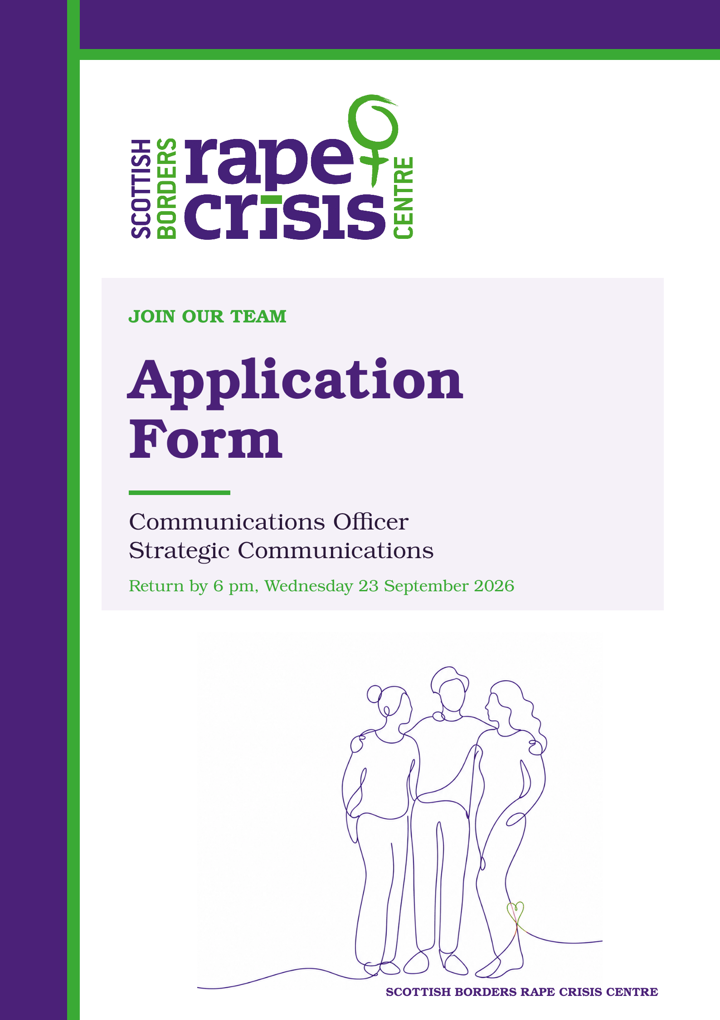
Communications Officer - Strategic Communications
Application Form

To be emailed to: recruitment@sbrcc.org.uk

by: 6 pm, Wednesday 23 September 2026

Section 1: Personal details
First Name: | Surname:
Address: | Tel (home)
Address: | Tel (mobile):
Postcode: | Email:

Section 2: Qualifications and training
(only enter those qualifications and/or training necessary or relevant to the job)
Qualification and/or training |  |  | Subject |  | Date
Section 3: Present employer
Name & address of employer: |  |  |  | Date commenced employment:
Job title: |  |  |  | Notice required: |  | Current salary:
Brief description of your main duties and responsibilities, with an emphasis, where possible, on those areas most relevant to this role.

Section 4: Previous employment (list in order, with most recent employer first)
Please list all your previous employment, detailing any gaps between employment with reasons.
Dates |  | Name and address of employer |  | Job title and nature of work |  | Reason for leaving
From  DD/MM/YY | To  DD/MM/YY |  |  |  |  | Reason for leaving

Section 5: Relevant skills, experience and abilities
Taking close account of the job description and person specification, please outline how your work experience, (including unpaid work) skills and abilities would enable you to carry out the duties of this post. Please include any information which you feel is relevant.
Section 6: References
SBRCC requires a minimum of 2 employment references to cover a three-year period – if necessary, please provide further referees covering the last 3 years.
Reference 1: Current / most recent employer
Name: | Position:
Email: | Tel No.
Company name: | Address:
Reference 2: Previous employer / supervisor
Name: | Position:
Email: | Tel No.
Company name: | Address:
Reference 3: Previous employer / supervisor
Name: | Position:
Email: | Tel No:
Company name: | Address:

Section 7: Declaration
I certify that all the information contained in this form and any attachments is true and correct to the best of my knowledge. I realise that false information or omissions may lead to dismissal.

Signature:

Date:

Section 8. Equality & Diversity Monitoring Form (Optional)
SBRCC is committed to promoting diversity and inclusion in hiring and service provision. To assist us to monitor the effectiveness of our equality and diversity practices we would encourage you to complete this monitoring form. Please note completion of our Equality & Diversity form is optional and does not form part of your application.

If you are happy to complete this form, please use the link below:
https://www.surveymonkey.co.uk/r/9G5T8PN

Section 9: Additional Information
The following question is for information and planning purposes only and is not essential for this role.

Please indicate whether you hold a full, valid driving licence and have regular access to a car:

☐ Yes – I hold a full, valid driving licence and have regular access to a car.
☐ I hold a full, valid driving licence but do not have regular access to a car.
☐ I do not hold a full, valid driving licence.
☐ Prefer not to say.

Completed applications should be emailed to recruitment@sbrcc.org.uk, handwritten applications should be posted to:

F.A.O Susie Stein, Chief Executive Officer
Scottish Borders Rape Crisis Centre, 1A Wilderhuagh, Galashiels, TD1 1PW

